Asset References:

Fonts:

[Noto Sans - Google Fonts](https://fonts.google.com/noto/specimen/Noto+Sans) (Noto Sans Regular)

Header:

Logo: Myself, with Reference to IKEA real logo

3bar, Bag, Heart, People, Search Icon: Iconduck Plugin

Footer:

Copyright, FB, Instagram, Tiktok, YouTube, X: Iconduck Plugin

Header:

Promotion1: [IKEA S'pore launches Online Sale from Jun 1, has over 500+ items up to 50% off for a limited time | Great Deals Singapore](https://www.greatdeals.com.sg/2020/06/01/ikea-online-sale-jun-2020)

Promotion2: [IKEA’s sale starts from 2 – 19 Aug 2018 (singpromos.com)](https://singpromos.com/department-stores/ikeas-sale-starts-from-2-19-aug-2018-219487/)

Promotion3: [Offers and promotions | IKEA Philippines - IKEA](https://www.ikea.com/ph/en/campaigns/)

Promotion4: [IKEA Tebrau | Get Home Furniture Ideas or Buy Online - IKEA](https://www.ikea.com/my/en/stores/tebrau/offers-and-events-pub18fbbccc)

Category:

Food Container, Cushions, Plants and Flowers, Small Storage: AI generated by StableDiffusionXL

Gallery:

Droan, Jarrad, Rdasen, Beljallet: AI generated by StableDiffusionXL

Jientei: [RÅSKOG Utility cart, white, 13 3/4x17 3/4x30 3/4" - IKEA](https://www.ikea.com/us/en/p/raskog-utility-cart-white-20382932/)

Kaivrao: [JOLPEN Loveseat, outdoor, white/gray, 393/8x231/4x263/8" - IKEA](https://www.ikea.com/us/en/p/jolpen-loveseat-outdoor-white-gray-60515483/)

Joftitme: [MICKE Desk, white, 413/8x195/8" - IKEA](https://www.ikea.com/us/en/p/micke-desk-white-80213074/)

Hirmagmu: [UTESPELARE Gaming desk and chair, black - IKEA](https://www.ikea.com/qa/en/p/utespelare-gaming-desk-and-chair-black-s19440706/)

Linanes: [LINANÄS Loveseat, Vissle beige - IKEA](https://www.ikea.com/us/en/p/linanaes-loveseat-vissle-beige-00512232/)

Ribba: [RIBBA Frame, white, 12x16" - IKEA](https://www.ikea.com/us/en/p/ribba-frame-white-90378427/)

About Us:

ILKEA2010: AI generated by StableDiffusionXL

Linanes: [LINANÄS Loveseat, Vissle beige - IKEA](https://www.ikea.com/us/en/p/linanaes-loveseat-vissle-beige-00512232/)

Member:

Store: <https://lh3.googleusercontent.com/p/AF1QipNpeeOELVRUcE9pl0jbMZanjXPfjhHUTajwCPUP=s1360-w1360-h1020>

Contact Us:

Makassar: <https://lh3.googleusercontent.com/p/AF1QipNpeeOELVRUcE9pl0jbMZanjXPfjhHUTajwCPUP=s1360-w1360-h1020>

Binjai: [หาบ้านสุดคุ้ม ดูแล้วจบที่ “ถนนวัดลาดปลาดุก” (home.co.th)](https://www.home.co.th/hometips/topic-4954)

Jonggol: [File:The world's largest IKEA near the KTX Gwangmyeong Station, Seoul Capital Area, South Korea.jpg - Wikimedia Commons](https://commons.wikimedia.org/wiki/File:The_world's_largest_IKEA_near_the_KTX_Gwangmyeong_Station,_Seoul_Capital_Area,_South_Korea.jpg)

Jakarta Garden City: [IKEA Pastikan Tak Semua Harga Produknya Naik Tahun Ini Halaman all - Kompas.com](https://www.kompas.com/properti/read/2022/01/09/150000821/ikea-pastikan-tak-semua-harga-produknya-naik-tahun-ini-?page=all)

Klaten: [IKEA ranked No.1 retailer brand in KSA | Arab News](https://www.arabnews.com/node/1060776/corporate-news)

Notes

The website is better suited to landscape mode. It’s been optimized in phones except for Portrait due to the structure that better suited Laptop. Optimizing for the portrait mode requires more extensive overhaul.

Documentation

Header



Footer

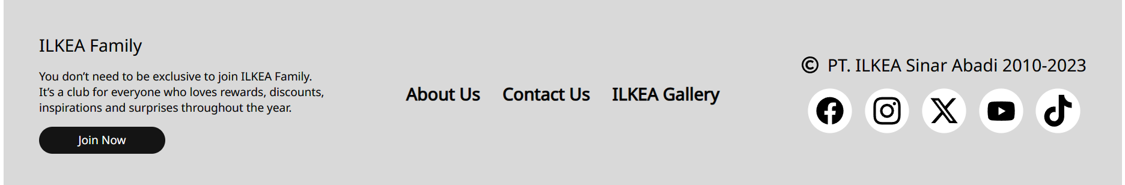

Home Slideshow

Home: Brand

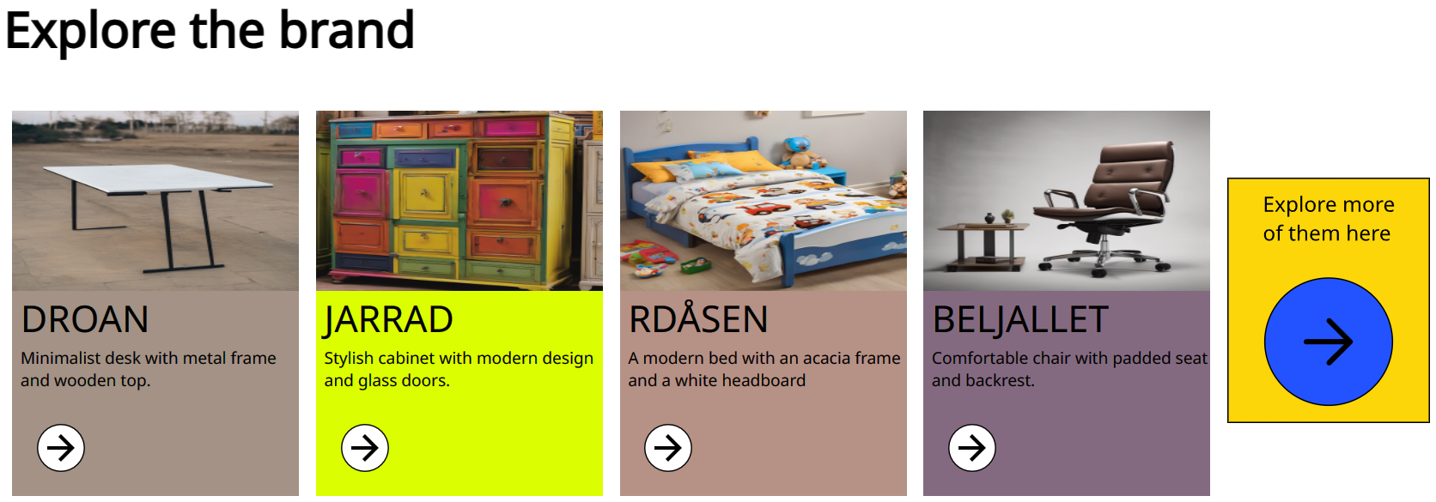

Home: Category

Home: Furniture

Home: Brief Description

Contact Us: First Row

Contact Us: Second Row

About Us: What is ILKEA?

About Us: Premium Products

Gallery: First Row

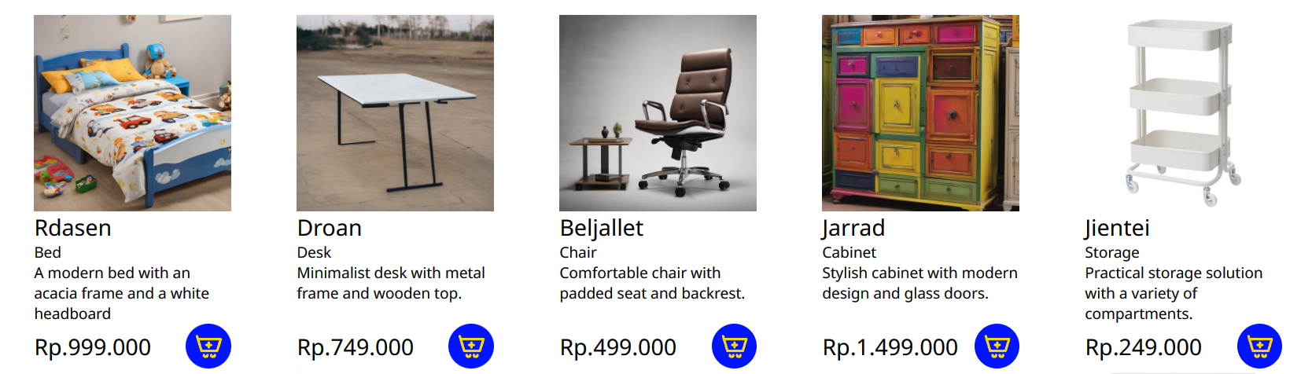

Gallery: Second Row

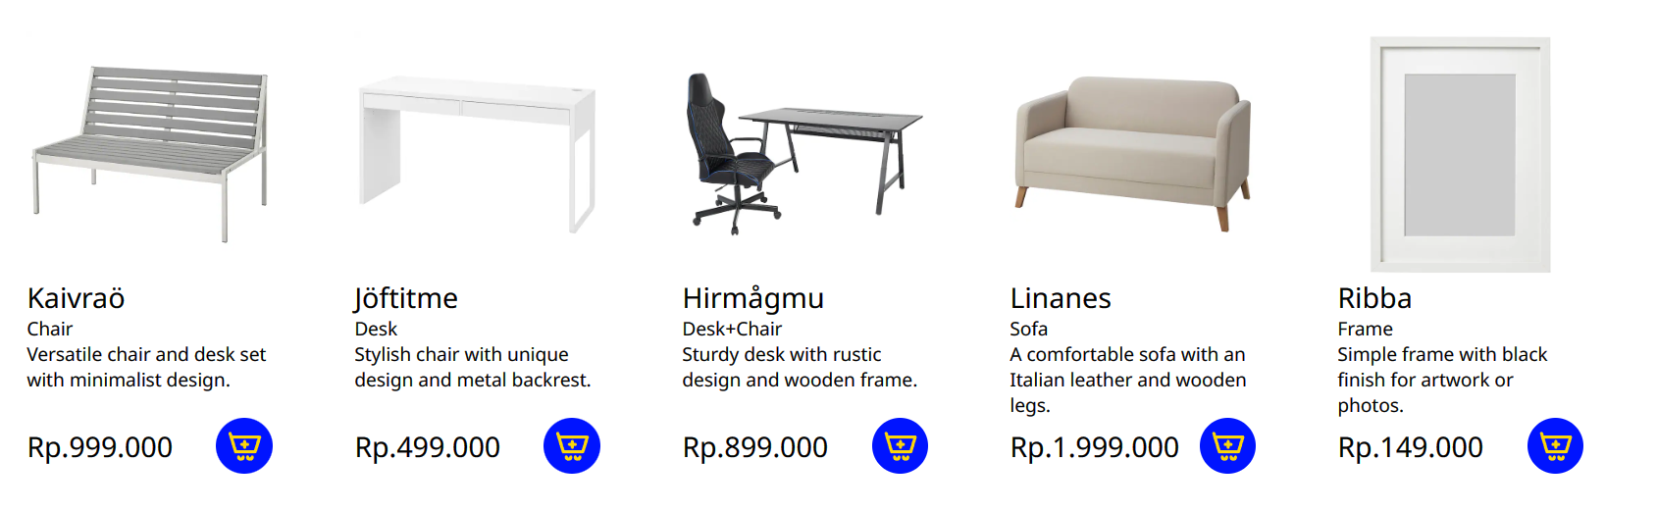

Member:

